**Full Stack Development with MERN**

**Frontend Development Report**

|  |  |
| --- | --- |
| Date |  |
| Team ID |  |
| Project Name | StreamSavvy |
| Maximum Marks |  |

**Project Title: StreamSavvy**

Date:

created by: Siddhant Udaykumar Patil

**Objective**

The objective of this report is to document the frontend development progress and key aspects of the user interface (UI) and User experience (UX) design is the process design teams use to create products that provide meaningful and relevant experiences touser.For an frontend project, the objectives typically center around delivering a user-friendly, interactive, and responsive interface that enhances the content streaming experienceUs=

k------expe

**Technologies Used**

* **Frontend Framework:** React.js
* **State Management:** [Redux/Context API, if applicable]
* **Ux framework :** figma

Project structure

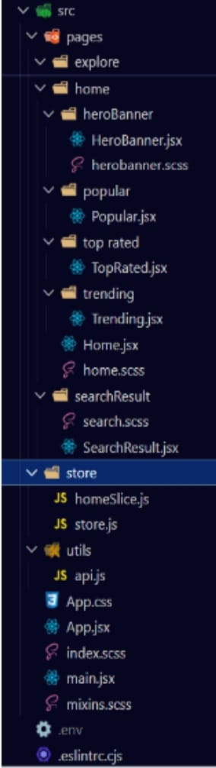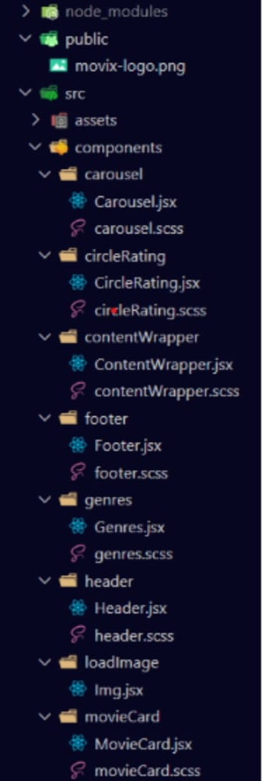





**Routing**

* **Home** - Landing page of the application ans search bar
* **Dashboard** – in our project in the dashboard you can see the homepage,movies icon,tv-searies,trending shows,popular shows.

--------------------------------------------------------------------------------------------------------------